**10. REACTJS-HQL**

**FOLDER STRUCTURE**

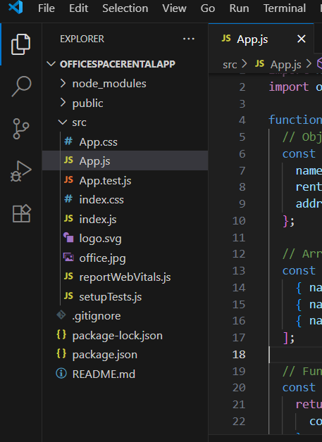

App.js

import React from 'react';

import officeImg from './office.jpg';

function App() {

  const office = {

    name: "GreenView Co-working",

rent: 55000,

    address: "3rd Cross, MG Road, Bangalore"

  };

  const officeList = [

    { name: "TechNest Hub", rent: 45000, address: "Whitefield, Bangalore" },

    { name: "EliteSpaces", rent: 65000, address: "Anna Nagar, Chennai" },

    { name: "WorkBay", rent: 60000, address: "Hitech City, Hyderabad" }

  ];

  const getRentStyle = (rent) => {

    return {

      color: rent < 60000 ? 'red' : 'green'

    };

  };

  return (

    <div style={{ padding: '20px', fontFamily: 'Arial' }}>

      <h1>🏢 Office Space Rental App</h1>

      <img src={officeImg} alt="Office Space" width="300" />

      <h2>Featured Office:</h2>

      <p><b>Name:</b> {office.name}</p>

      <p><b>Rent:</b> <span style={getRentStyle(office.rent)}>{office.rent}</span></p>

      <p><b>Address:</b> {office.address}</p>

      <h2>All Office Listings:</h2>

      {officeList.map((item, index) => (

        <div key={index} style={{ border: '1px solid #ccc', margin: '10px', padding: '10px' }}>

          <p><b>Name:</b> {item.name}</p>

          <p><b>Rent:</b> <span style={getRentStyle(item.rent)}>{item.rent}</span></p>

          <p><b>Address:</b> {item.address}</p>

        </div>

      ))}

    </div>

  );

}

export default App;

**OUTPUT**

